Produced for

Faulksy's
Travel Services

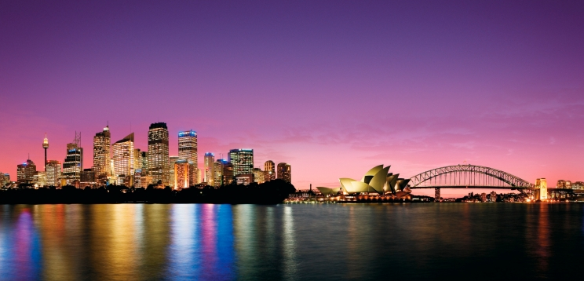

Prepared by
Peter J Faulks
July, 2026

TABLE OF CONTENTS
The Australian Alps 1
Ski the Australian Alps 1
The Blue Mountains 3
The Three Sisters 3
Sydney 4
Sydney Cove 4
Sydney’s Beaches 4
THE SNOWY MOUNTAINS 4
South Eastern Victoria 4

The Australian Alps
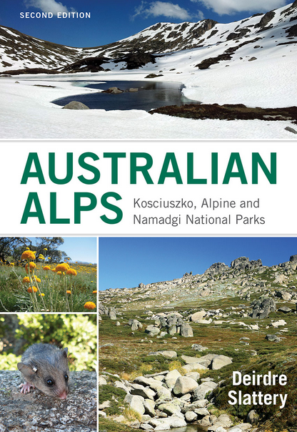
Kiandra, New South Wales is a humble little township high in the Australian Alps which has a special claim to be noted in the history of skiing, for it was here that the world's second-oldest ski club was formed.

In 1860 or thereabouts, soon after the first ski club was established in Norway, a Norwegian miner, reputed to be related to Amundsen of Arctic and Antarctic fame, was living in Kiandra, then a town of some 10,000 fortune-bent inhabitants, With some of the other miners, whom he had taught to ski, he formed the Kiandra Ski Club.
Ski the Australian Alps
Today, skiing has many active disciples in Australia; at Thredbo and Kosciusko, huge sums of money are invested by companies who believe that skiing will soon become one of the major sports of the country. Thredbo, in fact, already has the appearance of a Tyrolean alpine village - set in gum trees!
For more information on our Ski Resort Holidays:
Contact Gunter at our Kiandra Hostel
Tel: (071) 798 588

TRANSPORT DETAILS
(Times are approximate - please confirm before travel)
Bus |  | Train
Mon - Fri | Every ½ hr from the city centre  Commencing 6 am | Mon-Fri | Every 3 hrs from Central Station  Commencing 6am
Sat -Sun | Every 4 hrs  Commencing 7am | Sat-Sun | Every 4 hrs  Commencing 7am

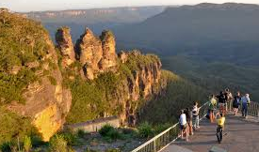

The Blue Mountains

The Blue Mountains are a heavily-indented spur of the Great Dividing Range. The mountains derive their name from the hazy blue which Sir Arthur Streeton, Elioth Gruner and other Australian artists have so successfully transferred to their canvases.

The Three Sisters
The triassic sandstone formation, known as the Three Sisters, rises 1,000 feet almost vertically from the floor of the Jamieson Valley; it is one of the outstanding attractions of the Blue Mountains area.

For more information on visiting the Blue Mountain range:

Contact Melissa at our Sydney branch
Tel: (02) 9587 6887

TRANSPORT DETAILS
(Times are approximate - please confirm before travel)
Bus |  | Train
Mon - Fri | Every 2 hrs from the city centre  Commencing 7am | Mon-Fri | Every 3 hrs from Central Station  Commencing 6am
Sat -Sun | Every 4 hrs  Commencing 7am | Sat-Sun | Every 4 hrs  Commencing 7am

Sydney

Built around the 183-mile foreshores of Port Jackson, in a setting which has been admired and envied by people from every nation, is Sydney, oldest and largest city of the Australian Commonwealth.

Sydney Cove
In and about Sydney Cove, where the first settlement was established, many modern buildings are mushrooming up against the ever-changing skyline. Here also, at the eastern end of the cove and overlooking the harbour, is the Sydney Opera House - as modern as tomorrow. But Government House looks more like an English castle.

Sydney’s Beaches
Only 35 miles from the mountains and for many Sydney-siders only minutes to a beach, Sydney is a city of contrasts. From the spacious baronial homes of its most successful businesmen to attic flats in crowded, cosmopolitan, Kings Cross - from the tranquillity of its harbour bays to the continuous roar of traffic crossing its gigantic steel bridge, this is a fabulous city.

THE SNOWY MOUNTAINS

A tremendous engineering project, the biggest ever undertaken in Australia, has been carried out in southern New South Wales and northern Victoria. This is the Snowy Mountains Scheme, a combined irrigation and hydro-electric power-generation system which cost about £500,000,000.
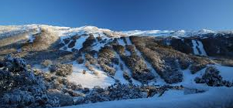
South Eastern Victoria

In the heart of the Australian Alps, the waters of the Snowy River and its tributary, the Eucumbene, have been re-routed away from their normal course through well-watered country in south-eastern Victoria, where they are not needed. Instead, they have been diverted through the mountains to augment the flow of the Murray and Murrumbidgee rivers by about 2,000,000 acre-feet each year, for use in their dry but fertile valleys.

Before being released for this purpose, the water will have passed through some of the series of tunnels totalling eighty-five miles; it will have been held in one or more of the seven larger and twelve smaller dams; and it will have produced electricity in fifteen power stations.

TRANSPORT DETAILS
(Times are approximate - please confirm before travel)
Bus |  | Train
Mon - Fri | Every 2 hrs from the city centre  Commencing 7am | Mon-Fri | Every 3 hrs from Central Station  Commencing 6am
Sat -Sun | Every 4 hrs  Commencing 7am | Sat-Sun | Every 4 hrs  Commencing 7am

A
Australian Alps, 5
B
Blue Mountains, 3
J
Jamieson Valley, 3
K
Kiandra, 2
Kings Cross, 4
Kosciusko, 2
P
Port Jackson, 4
S
Snowy Mountains, 5
Sydney Opera House, 4
T
Thredbo, 2
Three Sisters, 3

